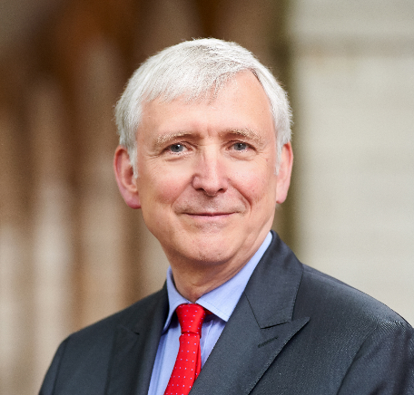
Mr. Denys Hickey
Year of birth: 1975
Email: denys.hickey@39essex.com

Denys has over forty years legal experience, with a strong reputation for arbitration. Denys is very well known for oil and gas and commodity trading work as well as for fraud and general commercial disputes.
Upstream oil and gas work has included advising on FPSO agreements, Supply time charters and LNG vessel charters. He has also advised on offshore construction joint ventures, the financing of refinery projects, disputes relating to offshore oil and gas projects, shipbuilding contracts, oilfield redetermination problems and pipeline construction disputes. Cases handled cover a very wide spectrum from shipping through insurance, oil trading and other commodity disputes together with engineering matters and shipbuilding contracts and disputes. Denys has also dealt with joint venture and shareholder disputes and with the breakup of offshore oil and gas and construction JV’s. Denys also has a wealth of experience of shipping and shipbuilding disputes as well as marine and energy insurance matters.
Recent work includes both representing parties and acting as counsel in ad hoc arbitrations and arbitrations under ICC, SIAC, KLRCA, SCMA, LCIA, LME, UNCITRAL, GAFTA, FOSFA and LMAA rules. He regularly sits as an arbitrator and is a CIArb Accredited Mediator.
He is a Board Member of Maxwell Chambers, and a on the Panel of Arbitrators with SIAC, KLRCA, SCMA and the London Metal Exchange (LME

ADR
He has extensive experience of international arbitration and mediation. Arbitration experience includes both representing parties and acting as counsel in ad hoc arbitrations and arbitrations under ICC, SIAC, SCMA, LCIA, LME, UNCITRAL, GAFTA, FOSFA and LMAA rules. Denys has also litigated challenges to arbitration awards on the grounds of alleged misconduct. He has also has sat as an arbitrator, and has been appointed as sole arbitrator in a number of SIAC and SCMA arbitrations. He is also a CIArb Accredited Mediator.

